Preparing a paper for IIIAE 2016

Katsufumi H. Daon¹⁾, Takahiro Kenon¹⁾ Hisafumi A. Katsura²⁾, Hanako Syuhasu²⁾ and Yoshiaki N. Hashimoto³⁾
1) Kyoto University, C3-b4S16, Nishikyo-ku, Kyoto, 615-8540, Japan.
2) Hokkaido University, N13 W8, Kita-ku, Sapporo, 080-8628, Japan.
3) KK Engineering Co., Ltd., 1-1, N18 E17, Tokyo, Japan, 145-0063, Japan

ABSTRACT: This document provides information and instructions for preparing a paper to be included in the Proceedings of IIIAE 2016. The paper has to be made as Microsoft Word.doc file. For the convenience of the authors, this template files for MS Word is provided. The paper itself begins at the top of the present page. All the instructions are given in the present file. The abstract should not exceed 6 lines (about 100 words). Do not begin a new line in this section and re-size this text box.

GENERAL SPECIFICATIONSS

Type area, typesize and typefont
The text should fit exactly into the type area of 17 x 25 cm. Pay attentions to the margins, where the top and bottom margins must be set with 20mm and the left and right margins with 20mm as well. The paper including figures, tables and references must have a length of 4 or 6 pages with A4 size.
Use Times New Roman or Symbol 10.5 point size in all text of the document with 12 point line spacing.

Title, Author and Affiliation
The title should be written left aligned with 18 pt, boldface Times New Roman. It should be single spaced if the title is more than one line long.
The author's name should include first name, middle initial if any, and surname. It should be written left aligned, in 10.5 pt Times New Roman. Author's affiliations should be written left aligned, in 10.5 pt Times New Roman.
Type the correct affiliation (Name of the institute, City, State/Province, zip code, Country). Main text in each column must be justified.

Format of the main text

Main headings and Secondary headings
The main headings should be written left aligned with 12 pt in capital. Don’t use ALL CAPS for the other text or headings. Secondary headings should be also written left aligned, 12 pt, Times New Roman, with an initial capital for first word only. Further headings should not be used.
Adding and editing the heading tags in your draft, they must be followed the same editorial manner in this sample to ensure the spacing between them.

Text
The first line of each paragraph must be indented 5mm. There is not inter-paragraph spacing. Do not put page numbers in this document. Preferable margins are 25 mm for top & bottom and 20 mm in both sides for A4 format.

Tables, Figures and Photographs

Tables and Figures
Keep tables simple. Range tables and table headings left. Do not spread tables out across the page. Type the table number and title immediately above the table. All tables should be numbered consecutively and captioned; the caption should be 10.5 pt Times New Roman, upper and lower case letters.
It is needed to locate tables and figures close to the first reference to them in the text and number them consecutively as “Table 1” and “Figure 1” (e.g., Table 1, Table. 2, …and, Figure 1, Figure. 2…) in both main text and captions (See the following examples in Table 1 and Figure 1).
(1 blank line)
Table 1: Example of construction of a table
(1 blank line)
All illustrations including figures and photographs should be placed in the text near where they are first mentioned. All of them should be numbered consecutively and captioned as same as tables explained above. All the illustrations must be embedded in the lines and another extra blank line should be inserted at top and bottom of the illustrations. Do not separate the figures or tables and the caption over the pages.

Black/white or full-color
The proceedings will be printed in black only. For this reason, it is recommended to avoid the use of color in figures and photographs. But if needed, they can be in full-color when saved in memory disk of the IIIAE 2016 proceedings. Please insert the high resolution figures (see artwork document) in the word file.
(1 blank line)
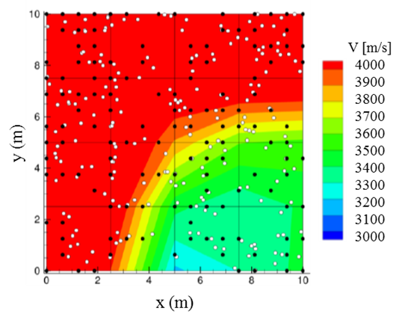
Figure 1: Identified elastic wave velocity distribution and source locations on heterogeneous anisotropic model [1]
(1 blank line)

Equations and Units
Use the equation editor of the selected word processing program. Equations are not indented. Number equations consecutively in round brackets and place the number with the tab key at the end of the line, between parentheses. See for example Equation 1 [2] below.
Use SI units. Use correct abbreviations for units ("%" and not "percent").
(1 blank line)
(1)
(1 blank line)
where D_{e}: Effective diffusion coefficient [m²/s], D_{f}: Diffusion coefficient in free water [m²/s], δ: Connectivity, τ: Tortuosity and θ: Void ratio
(1 blank line)
The symbols of variables for formulas in the text should be written in italics. Do not use the equation editor between texts on same line. Equations and the definitions of variables should be separated with 1 empty line from the other text.

conclusions
These formatting instructions must be followed by the authors.
The full paper submission of the IIIAE 2016 will be only accepted by a PDF file. The full draft paper must be submitted by June 30, 2016 via the symposium web site (https://ssl-agmedia.com/iiiae2016/cp/). When submitting the full paper, a completed Copyright Transfer Form, which can be downloaded via symposium web site, should also be included.

ACKNowledgements
The “Acknowledgments” section must be placed right before the “References” section. Do not number the caption for “Acknowledgements” and “Conclusions”. References should be typed at the end of the paper and numbered as in text-shown order.

References
- Kobayashi, Y., Shiotani, T., (2015) “Verification of Composite AE-Tomography on Varying Anisotropy of Elastic Wave Velocity”, Proceedings of the 7th Asia Pasific Young Researcher and Graduates Symposium, pp.474-482.
- Garboczi, E. J. and Bentz, D. P., (1992). “Computer simulation of the diffusivity of cement-based materials.” Journal of Materials science, Vol.27, pp.2083-2092.

